Mobile Network - Internet Gateway

🌐 What Is an Internet Gateway?
# Source: Chatgpt (GPT-5-Mini) at [1/23/2026]
An Internet Gateway is a device or system that acts as a bridge between a private/internal network (like a mobile network or enterprise LAN) and the public internet. It routes data traffic between users and internet services and may also perform functions like address translation, firewalling, and traffic control.
Think of an internet gateway as the doorway between your device and the global internet.

🔧 What Does an Internet Gateway Do?
# Source: Chatgpt (GPT-5-Mini) at [1/23/2026]
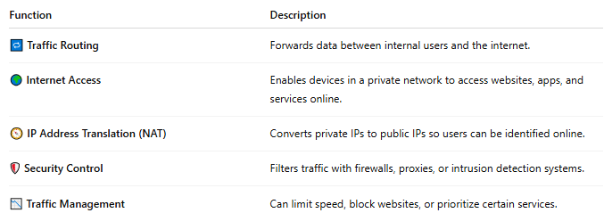

Function | Description
🔁 Traffic Routing | Forwards data between internal users and the internet.
🌍 Internet Access | Enables devices in a private network to access websites, apps, and services online.
🧭 IP Address Translation (NAT) | Converts private IPs to public IPs so users can be identified online.
🛡️ Security Control | Filters traffic with firewalls, proxies, or intrusion detection systems.
📉 Traffic Management | Can limit speed, block websites, or prioritize certain services.

📡 Where It Fits in a Mobile Network:
# Source: Chatgpt (GPT-5-Mini) at [1/23/2026]
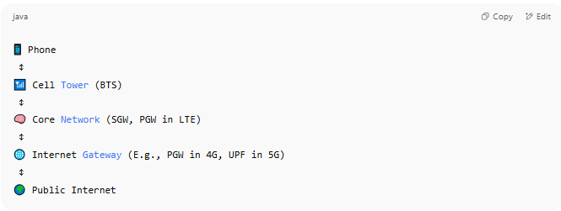
📱 Phone
↕
📶 Cell Tower (BTS)
↕
🧠 Core Network (SGW, PGW in LTE)
↕
🌐 Internet Gateway (E.g., PGW in 4G, UPF in 5G)
↕
🌍 Public Internet

- In 4G LTE, the PGW (Packet Gateway) acts as the internet gateway.
- In 5G, this is handled by the User Plane Function (UPF).

🏠 Examples of Internet Gateways:
# Source: Chatgpt (GPT-5-Mini) at [1/23/2026]
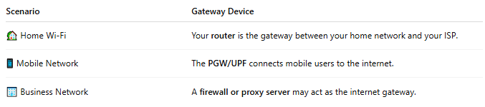

Scenario | Gateway Device
🏡 Home Wi-Fi | Your router is the gateway between your home network and your ISP.
📱 Mobile Network | The PGW/UPF connects mobile users to the internet.
🏢 Business Network | A firewall or proxy server may act as the internet gateway.

📖 Summary:
# Source: Chatgpt (GPT-5-Mini) at [1/23/2026]
An Internet Gateway is a critical access point that connects private networks to the internet. It handles:
- 🚪 Data flow in and out,
- 🧠 Address conversion (NAT),
- 🔒 Security filtering,
- 📊 Traffic control.
Without it, devices wouldn’t be able to access the web, stream videos, use apps, or communicate with external services.

